Causal Inference-Replication of Hansen (2015)

Wen-Hsin (Molly) Chang

Date: 2021.2.15

1. Create new Github repo named ” RDD”

https://github.com/wsmolly/RDD

1. Summary of the paper

The research question of this paper is whether the punishment severity has on commission of future crime. The author uses the data from the administrative records of drinking under influence (DUI) stops from the states of Washington from 1995 to 2011. The research design mainly follows the regression discontinuity approach, and the author relies upon the reasoning that drivers and officers are unable to manipulate the blood alcohol content (BAC). In conclusion, the author suggests that harsher punishment associated with BAC limits reduce future drunk driving.

1. Create a dummy equaling 1 if bac>=0.08 and 0 otherwise.

. use https://github.com/scunning1975/causal-inference-class/raw/master/  
 hansen_dwi, clear  
. gen DUI=1 if bac1>=0.08  
. replace DUI=0 if DUI==.

1. Replication of Figure 1: sorting the running variable

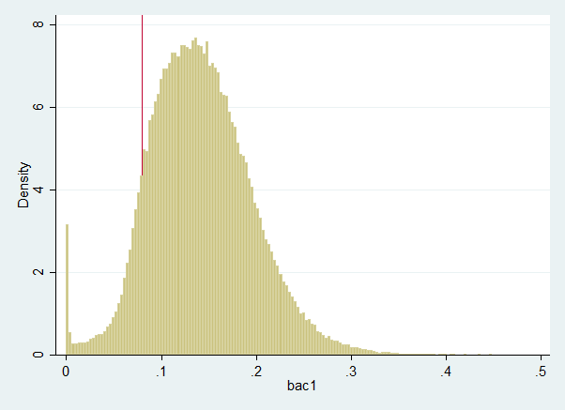

There seems to be no evidence for sorting on the running variable. Specifically, the distribution of bac1 is smooth around the 0.08 threshold. The result gives credence to Hansen’s regression discontinuity design.

1. Replication of Table2 :checking for covariate balance

|  |  |  |  |  |
| --- | --- | --- | --- | --- |
|  | (1) | (2) | (3) | (4) |
| VARIABLES | Male | White | Age | Accident |
|  |  |  |  |  |
| bac1 | -0.210 | 0.0788 | -69.16*** | -1.096*** |
|  | (0.234) | (0.224) | (6.862) | (0.176) |
| DUI | -0.0184 | 0.00445 | -6.224*** | -0.154*** |
|  | (0.0198) | (0.0173) | (0.585) | (0.0158) |
| DUI_bac1 | 0.307 | 0.0156 | 76.05*** | 1.888*** |
|  | (0.263) | (0.238) | (7.647) | (0.203) |
| Constant | 0.801*** | 0.840*** | 39.45*** | 0.171*** |
|  | (0.0151) | (0.0150) | (0.466) | (0.0118) |
|  |  |  |  |  |
| Observations | 89,967 | 89,967 | 89,967 | 89,967 |
| R-squared | 0.000 | 0.000 | 0.002 | 0.002 |

Robust standard errors in parentheses

*** p<0.01, ** p<0.05, * p<0.1

We can see that the coefficient of DUI is significant for Age and Accident and insignificant for Male and White. Therefore, covariate balance seems to hold under Male and White, while it does not hold for Age and Accident. The result is different from Hansen’s original result. I suspect one of the reasons may be the difference between our data set and Hansen’s original one.

1. Replication of Figure2 : BAC and characteristic

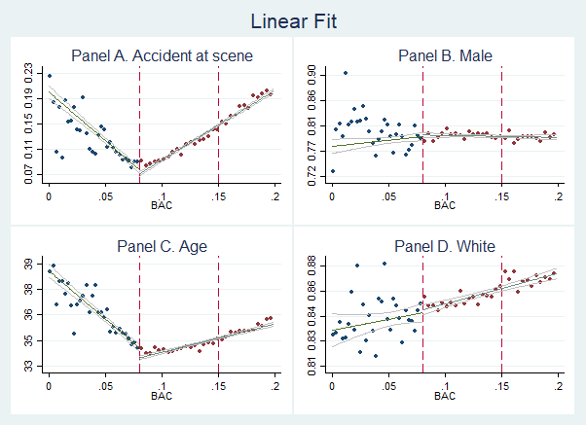

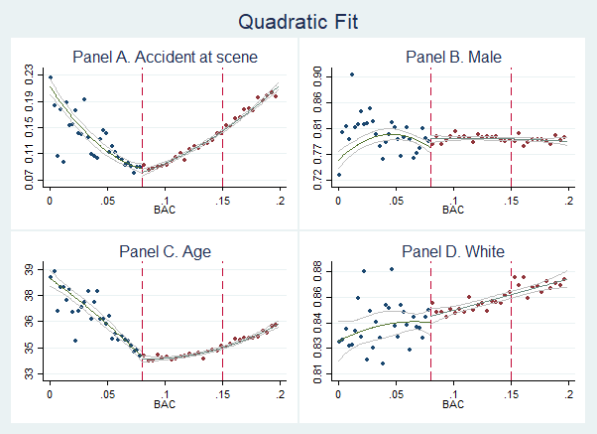

Although two of the variables violate covariate balance in our replication of table 2, the replication results of Figure 2 above seem quite similar to Hensen’s paper. Hensen does not use quadratic fits in his paper, but I suspect the quadratic model can serve a betterpurpose in projection.

1. Table3 Panel A:recidivism outcome (0.03 < bac1 < 0.13)

.

|  |  |  |  |
| --- | --- | --- | --- |
| Panel A  (bandwidth0.03-0.13) | (1) | (2) | (3) |
| VARIABLES |  |  |  |
|  |  |  |  |
| bac1 | 0.312*** | -0.0367 | 2.943* |
|  | (0.0748) | (0.187) | (1.638) |
| DUI | -0.0271*** | -0.0576*** | 0.116 |
|  | (0.00403) | (0.0152) | (0.0843) |
| DUI_bac1 |  | 0.420** | -4.276** |
|  |  | (0.204) | (2.112) |
| bac1sq |  |  | -25.01* |
|  |  |  | (13.74) |
| DUI_bac1sq |  |  | 33.09** |
|  |  |  | (15.11) |
| white | 0.0145*** | 0.0145*** | 0.0145*** |
|  | (0.00282) | (0.00282) | (0.00282) |
| male | 0.0326*** | 0.0325*** | 0.0326*** |
|  | (0.00233) | (0.00233) | (0.00233) |
| aged | -0.000854*** | -0.000860*** | -0.000860*** |
|  | (8.49e-05) | (8.50e-05) | (8.50e-05) |
| acc | 0.00456 | 0.00434 | 0.00431 |
|  | (0.00345) | (0.00345) | (0.00345) |
| year | -0.00268*** | -0.00267*** | -0.00267*** |
|  | (0.000411) | (0.000411) | (0.000411) |
| Constant | 5.456*** | 5.455*** | 5.378*** |
|  | (0.823) | (0.823) | (0.824) |
|  |  |  |  |
| Observations | 89,967 | 89,967 | 89,967 |
| R-squared | 0.004 | 0.004 | 0.004 |
|  |  |  |  |
| Panel B  (bandwidth0.055-0.105) | (1) | (2) | (3) |
| VARIABLES |  |  |  |
|  |  |  |  |
| bac1 | 0.177 | -0.194 | 6.124 |
|  | (0.201) | (0.382) | (8.113) |
|  |  |  |  |
| DUI | -0.0217*** | -0.0628* | 0.379 |
|  | (0.00558) | (0.0350) | (0.422) |
| DUI_bac1 |  | 0.530 | -10.66 |
|  |  | (0.449) | (10.60) |
| bac1sq |  |  | -45.74 |
|  |  |  | (58.70) |
| DUI_bac1sq |  |  | 71.86 |
|  |  |  | (69.16) |
| white | 0.0156*** | 0.0156*** | 0.0156*** |
|  | (0.00383) | (0.00383) | (0.00383) |
| male | 0.0349*** | 0.0349*** | 0.0349*** |
|  | (0.00317) | (0.00317) | (0.00317) |
| aged | -0.000761*** | -0.000763*** | -0.000764*** |
|  | (0.000115) | (0.000115) | (0.000115) |
| acc | 0.00416 | 0.00408 | 0.00409 |
|  | (0.00496) | (0.00496) | (0.00496) |
| year | -0.00299*** | -0.00299*** | -0.00299*** |
|  | (0.000567) | (0.000567) | (0.000567) |
| Constant | 6.087*** | 6.103*** | 5.890*** |
|  | (1.136) | (1.137) | (1.172) |
|  |  |  |  |
| Observations | 46,957 | 46,957 | 46,957 |
| R-squared | 0.005 | 0.005 | 0.005 |

In Panel A, the coefficient of DUI is significantly negative in column 1 and 2, indicating that there is a decrease in recidivism due to the punishment of exceeding the 0.08 BAC threshold. However, it is interesting that the coefficient of DUI becomes insignificant when including quadratic interaction. A further examination will be needed to determine whether it is appropriate to model the punishment effect using quadratic approximation. Overall, the results indicate the effectiveness of 0.08 BAC punishment on recidivism at least in the linear case.

As for Panel B, we can see that the coefficient of DUI becomes marginally significant in column (2), where we control for the interaction between bac1 and DUI, and insignificant in column (3), where we control for the quadratic interaction between bac1 and DUI. According to Table 3, we may infer that the regression discontinuity design is sensible to the bandwidth, but column (1) closely replicates Hensen’s original result.

1. Replication of Figure3: BAC and Recidivism

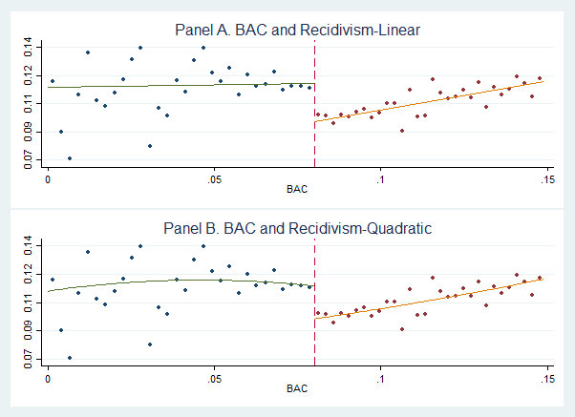

Our replication of Figure 3 shows a salient plunge in recidivism either using linear fit or quadratic fit. The result is qualitatively similar to that of Hensen’s, and indicates that the BAC 0.08 punishment threshold is effective in reducing recidivism. However, it is also worth noting that when offenders are way above the BAC 0.08 punishment threshold, they become more likely to recidivate

1. Conclusion

This replication exercise is very helpful to understand the intuition and the mechanism behind the RDD design. Moreover, I benefit from getting more familiar with STATA commands. Consistent with Hensen’s hypothesis, I expect that DUI punishment is effective in reducing recidivism. However, the replication of the main table(Table 3) provides preliminary evidence showing that Hensen’s original conclusion may be sensible to model specification (linear vs quadratic), and the underlying assumption of covariate balance may fail for some of the variables in our dataset. Overall, my results mostly support Hansen’s findings in linear model specification.